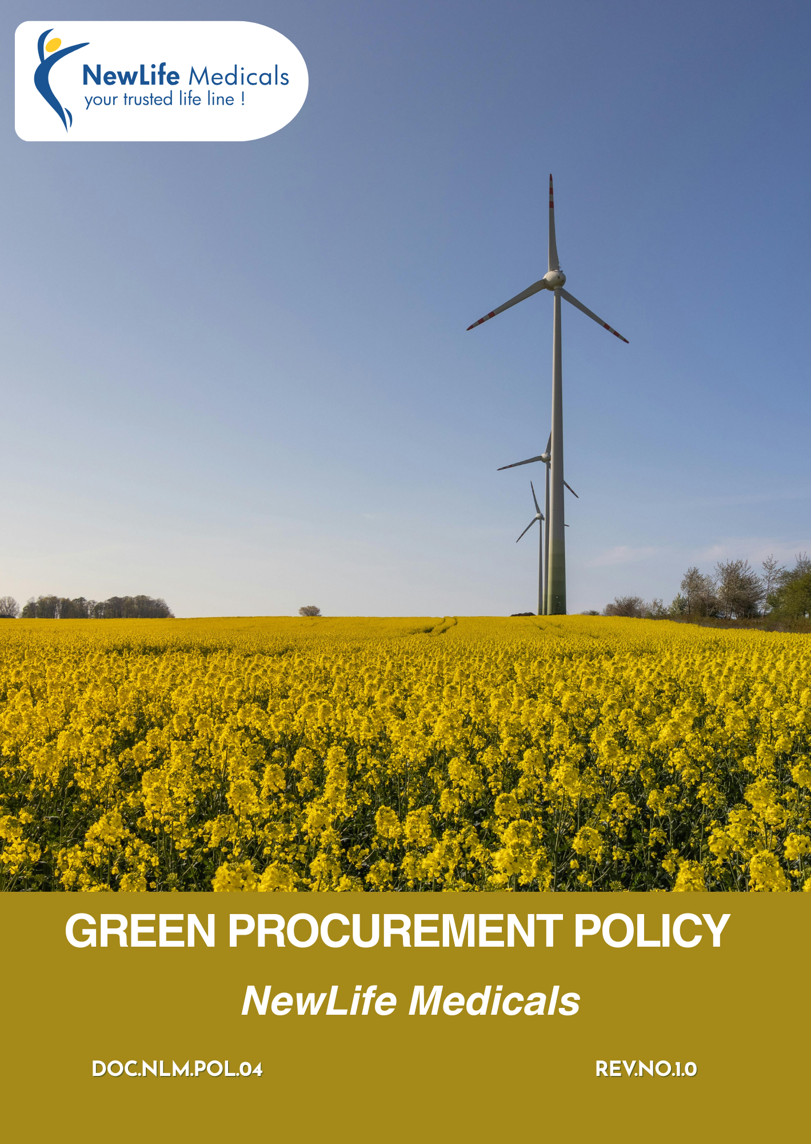

Table of Contents
Introduction 3
Purpose 3
Scope 3
Green Procurement Focus Areas 4
Qualitative Targets 4
Quantitative Targets 7
Governance & Responsibility 9
Reporting 10
Continuous Improvement & Monitoring 11
Policy Alignment with SDGs 11
Review 11
Employee Acknowledgement Form 12

Introduction
NewLife Medicals. is committed to incorporating environmental considerations into its procurement practices. As a pharmaceutical sourcing and distribution company, we recognize that our purchasing decisions have a direct impact on environmental sustainability across our value chain. Through this Green Procurement Policy, we aim to source products and services that minimize environmental impact, reduce waste, conserve resources, and comply with applicable environmental regulations. We encourage collaboration with suppliers who demonstrate responsible environmental practices and relevant certifications. By promoting sustainable sourcing, we strive to reduce our carbon footprint while maintaining quality, safety, and regulatory compliance standards.

Purpose
The purpose of this Green Procurement Policy is to:
- Formalize NewLife Medicals’s commitment to ethical, responsible, and sustainable procurement practices across its supply chain.
- Minimize environmental impacts associated with procured goods and services by promoting resource efficiency, waste reduction, emissions control, and responsible material management.
- Respect and protect human rights while promoting fair labor practices, safe working conditions, and ethical treatment of workers across the supply chain.
- Establish a structured framework to identify, assess, and manage sustainability-related risks and opportunities within procurement activities.

Scope
This Policy applies to all operations of NewLife Medicals, including its offices, warehouses, distribution activities, and global sourcing and supply chain operations. It is applicable to all employees, management, contract workers, business associates, and stakeholders, whether internal or external, working on behalf of the Company
Sr No | Group | Entity Name | Types | Address
1. | NewLife Medicals | NewLife Medicals Pvt Ltd | Offices | 1020 & 1021, 10th Floor, Maple Trade Center, Near Surdhara Circle, Thaltej, Ahmedabad – 380059
2. | NewLife Medicals | NewLife Medicals (USA), Inc | Offices | 146 Donmoor CT, Garner, North Carolina 27529, USA
3. | NewLife Medicals | NewLife Biopharma Limited | Offices | SKY Business Centre, Office 12, Unit 9a, Plato Business Park, Damastown, Dublin 15, Ireland D15 PA4C

Green Procurement Focus Areas
- Promoting reduced emissions, responsible resource use, waste management, and sustainable packaging across supplier operations.
- Integrating environmental, social, and governance (ESG) criteria into supplier onboarding, evaluation, and renewal processes.
- Ensuring suppliers adhere to fair labor practices, safe working conditions, and prohibition of child or forced labor.
- Ensuring procurement activities align with pharmaceutical regulations, export-import laws, trade compliance, and international standards.
- Strengthening documentation, auditability, and traceability in API sourcing, comparator drugs, and international logistics.
- Promoting recyclable, reusable, and environmentally responsible packaging and optimized shipment planning.
- Conducting environmental and social risk assessments, particularly in high-risk geographies and high-impact categories.
- Collaborating with suppliers to drive continuous sustainability improvements and long-term responsible partnerships.
- Establishing oversight mechanisms, sustainability KPIs, and periodic reviews to ensure accountability and continuous enhancement.

Qualitative Targets
  - Supplier Environmental Practices
- We are committed to integrating environmental sustainability considerations into supplier selection and evaluation processes, ensuring that procurement decisions align with responsible environmental stewardship principles.
- We aim to collaborate with suppliers who demonstrate compliance with applicable environmental laws and regulations, particularly in manufacturing, storage, packaging, and transportation of pharmaceutical products and APIs.
- We encourage suppliers to implement structured environmental management systems, such as ISO 14001 or equivalent frameworks, to promote systematic control of environmental impacts.
- We incorporate environmental protection clauses within our Supplier Code of Conduct and supplier contracts, requiring business partners to adhere to defined environmental standards, comply with applicable regulations, and support sustainable practices as a condition of engagement and continued business relationship.
- We strive to work with suppliers who actively reduce greenhouse gas emissions, air pollutants, and operational waste, especially in high-volume production and international logistics activities.
- We support the use of sustainable and recyclable packaging materials, minimizing environmental impact during export, storage, and distribution operations.
- We maintain periodic review and engagement mechanisms to assess supplier environmental performance, and we encourage continuous improvement through collaboration and knowledge sharing.
- We are committed to enhancing the awareness and capabilities of our procurement teams through regular training on environmental, sustainability, and responsible sourcing principles.
  - Supplier Social and Labor Practices
- We strive to engage suppliers who adhere to ethical labor practices and respect internationally recognized human rights standards.
- We are committed to engaging with suppliers who uphold fundamental human rights and fair labor standards, ensuring ethical treatment of workers across all stages of the pharmaceutical supply chain.
- We collaborate with suppliers who prohibit child and forced labor, ensure safe and healthy working conditions, and promote equal opportunity and non-discrimination, in compliance with applicable labor laws and international standards.
- We support the provision of fair wages, lawful working hours, and legally mandated benefits, ensuring alignment with local labor laws and recognized labor standards.
- We integrate labor and human rights requirements into our Supplier Code of Conduct and require all suppliers to formally accept and comply with these standards as a condition of business engagement.
- We encourage collaboration with suppliers that maintain recognized social and occupational health and safety certifications, such as ISO 45001, SA8000, Fair Wage Network, or equivalent frameworks.
- We support inclusive procurement practices by promoting engagement with women-owned, minority-owned, and other underrepresented businesses, where feasible.
- We strengthen responsible sourcing by providing ongoing training and awareness programs to procurement personnel on labor and human rights risks within the supply chain.
  - Sustainable Procurement Goals
- We will embed sustainability principles into all procurement activities, ensuring purchasing decisions align with our environmental, social, and ethical commitments.
- Adherence to our Supplier Code of Conduct will be mandatory across the supply chain to promote responsible, ethical, and transparent business practices.
- ESG requirements will be formally incorporated into supplier contracts and agreements, reflecting applicable legal obligations, regulatory developments, and recognized industry standards.
- We will implement risk-based supplier due diligence, including ESG self-assessments, audits, and periodic evaluations, to verify compliance and strengthen responsible sourcing practices.
- We are committed to eliminating child labor, forced labor, and human trafficking throughout the supply chain through contractual commitments, supplier declarations, and monitoring mechanisms.
- We aim to build long-term partnerships with suppliers who share our commitment to sustainability and continuous improvement.
- Wherever feasible, we will prioritize local and regional suppliers to support community development and reduce supply chain-related environmental impacts.
- We will continuously refine our procurement strategies to remain aligned with evolving sustainability standards and responsible sourcing expectations.
  - 4. Governance Goals
- We require suppliers to uphold high standards of business ethics, anti-corruption, anti-bribery, and regulatory compliance, integrated into supplier onboarding and contractual frameworks.
- We will conduct structured, risk-based due diligence and periodic assessments to monitor supplier compliance with governance and ethical expectations.
- We are committed to strengthening governance accountability by providing regular training and awareness programs for procurement personnel on ethical sourcing, governance risks, and anti-corruption practices.

Quantitative Targets
- Supplier Environmental Practices
- We target to assess the environmental compliance and sustainability practices of 90% of new suppliers and at least 50% of strategic and high-spend suppliers by 2029, against the baseline year 2023.
- We target to ensure that at least 30% of key suppliers implement a formal Environmental Management System (EMS), such as ISO 14001 or equivalent, by 2029, against the baseline year 2023.
- We aim to increase the proportion of suppliers adopting sustainable or recyclable packaging solutions to 65% of total procurement volume by FY 2029, against the baseline year 2023.
- We target to conduct environmental risk-based evaluations for 100% of suppliers operating in high-risk geographies or high-impact manufacturing categories annually starting 2025.
- We aim to achieve a 20% reduction in logistics-related carbon intensity (per shipment or per procurement value) by 2029, against the baseline year 2023, through supplier collaboration and route optimization.
- We target to engage at least 75% of strategic suppliers in environmental improvement initiatives or sustainability awareness programs by 2029, against the baseline year 2023.
- We are committed to ensuring that, by 2029, all procurement personnel (100%) complete training on environmental aspects relevant to procurement activities, using 2023 as the baseline year.

- Supplier Social and Labor Practices
- We target to assess compliance with social and labor standards for 90% of new suppliers and at least 80% of strategic and high-spend suppliers by 2029, against the baseline year 2023.
- We aim to ensure that 100% of identified high-risk suppliers formally acknowledge and commit to our Supplier Code of Conduct, including human rights and labor standards, by 2026, against the baseline year 2023.
- We are committed to achieving and maintaining zero cases of child labor within our supply chain through annual supplier due diligence, continuous monitoring, and compliance verification mechanisms.
- By 2029, we target sourcing at least 90% of our total procurement spend from suppliers holding recognized ethical certifications such as Fair Trade, SA8000, or equivalent standards, using 2023 as the baseline year.
- We are committed to ensuring that 100% of procurement personnel complete training on social responsibility, human rights, and ethical sourcing by 2029, benchmarked against our 2023 baseline.
- By 2029, we aim to integrate social and human rights requirements into our Supplier Code of Conduct and all supplier contracts, achieving full coverage across 100% of suppliers, measured against the 2023 baseline.

- Sustainable Goals for Procurement
- By 2029, we target conducting sustainability self-assessments and on-site ESG audits for at least 60% of high-spend suppliers, measured against our 2023 baseline.
- We aim to secure formal acknowledgment and compliance with our Supplier Code of Conduct from at least 70% of suppliers by 2029, benchmarked against 2023.
- We commit to incorporating enhanced ESG provisions into 100% of supplier contracts, with reviews conducted at least biennially or earlier in response to regulatory changes, achieving full alignment by 2029 compared to the 2023 baseline.
- By 2029, we will implement annual ESG performance evaluations for all suppliers to systematically monitor compliance and sustainability progress, using 2023 as the reference year.
- We will require corrective action plans from all non-compliant suppliers and aim to resolve at least 90% of identified issues within 12–15 months of detection.
- We target requiring all strategic suppliers to provide annual ESG disclosures or sustainability reports by 2029, measured against the 2023 baseline.
- Governance Goals
- By 2029, we aim to provide ethics and compliance training to at least 90% of procurement personnel, using 2023 as the baseline year.
- We target achieving 100% annual conflict-of-interest declarations from employees engaged in procurement activities by 2029, benchmarked against 2023.
- We will integrate ethics, compliance, and anti-corruption clauses into 100% of new supplier contracts by 2029, compared to the 2023 baseline.

Governance & Responsibility
Executive Management
- Provides strategic direction and approves the Green Procurement Policy.
- Allocates necessary resources for policy implementation, supplier engagement, and continuous improvement.
- Reviews overall procurement performance and ensures alignment with ESG and sustainability objectives.
- Supports cross-functional collaboration to achieve organizational sustainability goals.
Head of Procurement
- Holds accountability for implementation of the policy across all procurement activities.
- Review policy regularly
- Integrates sustainability and ESG criteria into supplier selection, contract terms, and performance evaluations.
- Oversees risk-based supplier segmentation, monitoring, and reporting.
- Drives capacity building and training for procurement teams on sustainable sourcing practices.
Procurement Managers & Buyers
- Apply sustainability requirements during sourcing, tendering, and purchasing decisions.
- Conduct supplier assessments, track corrective actions, and monitor progress.
- Engage suppliers on improvement initiatives, including environmental, social, and governance practices.
- Attend trainings regularly
EHS Head
- Ensure alignment with GMP, regulatory, environmental, health, and safety requirements.
- Participate in supplier audits, review remediation actions, and validate corrective measures.
- Support reporting and monitoring of supplier ESG performance.
- Advise procurement teams on risk mitigation and compliance gaps.
Suppliers
- Comply with all applicable laws, regulations, and the Supplier Code of Conduct.
- Provide accurate information, certifications, and support for audits and assessments.
- Implement corrective actions identified during audits and demonstrate continuous improvement.
- Adopt responsible practices in environmental management, labor standards, and ethical conduct.

Reporting
NewLife Medicals is committed to transparent and timely reporting on sustainable procurement. Supplier performance is monitored against ESG criteria, corrective actions are tracked, and sustainability initiatives evaluated. Procurement teams collect data, which senior management reviews to ensure alignment with ESG objectives. Key indicators, including supplier assessments and audit results, are reported internally and externally to drive accountability, continuous improvement, and informed decision-making.

Continuous Improvement & Monitoring
NewLife Medicals is committed to continuously improving sustainable procurement by monitoring supplier performance, internal processes, and policy effectiveness. ESG targets are tracked, gaps addressed, and corrective actions taken promptly. Regular audits, assessments, and stakeholder feedback inform procurement strategies, ensuring compliance, risk mitigation, and ongoing advancement of sustainability objectives.

Policy Alignment with SDGs




s

Review
This Green Procurement Policy undergoes a formal review at least once every year, or as per requirement by the Head of Procurement if there are significant changes in regulations, business operations, or the supply chain. The review ensures that the policy remains relevant, practical, and aligned with the strategic goals of NewLife Medicals.
Effective Date: 01 January 2025
Last review date: 01 January 2026
Next review date: 01 January 2027
Revision number: 1.0

Approved by:
Managing Director

Employee Acknowledgement Form
I acknowledge that I have received, read, and understood the Company’s Green Procurement Policy. I understand that this policy outlines expectations related to responsible sourcing, supplier environmental and social practices, ethical behavior, and compliance requirements.
I also acknowledge my responsibility to promptly report any suspected violations, unethical behavior, or supply-chain risks through the designated reporting channels, without fear of retaliation.
By signing below, I confirm my commitment to supporting sustainable and ethical procurement practices.
Department: ___________________________
Employee Name: ___________________________
Employee ID: ___________________________
Employee Signature: ___________________________
Date: ___________________________

